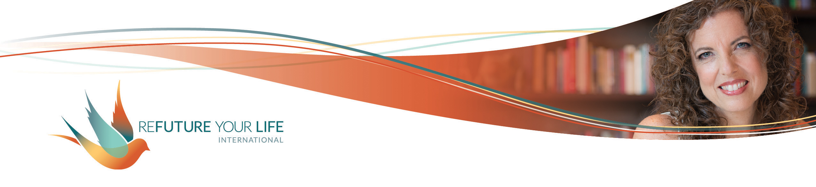

Finding Your North Star

Well, 2021 is off to an interesting start! As we know, times of great change are also times of great possibility. Your intentions and practices will play a very important role this year in keeping your grounded, aware and aligned, as will staying in the conversations we have every week.

I keep thinking of the metaphor of the sailboat with its deep, weighty keel. Both grounded and afloat, it’s able to use the power of a wind that might otherwise capsize it to move forward with great momentum. Your practices and intentions, and this work we do together, are developing your keel.

One deepening practice is to celebrate what got you through past challenges. Doing so will both remind you of what’s in your toolbox, and sharpen the tools you have. You can draw on these any time you want.

We’re then going to identify your north star – a guiding word (or words) for the year ahead. It may be your word of the year, or you may find a word that complements your WOTY. [Reach out to me if you aren’t familiar with the word of the year practice.] For example, my personal word of the year is afire. My North Star for the year is expression. I’ll practice living on fire this year. When I feel not afire, I’ll look to see where I’m not expressing myself as a way to reconnect with my fire. When I do feel afire, I’ll play with how it wants to be expressed in new and delight-giving ways!

Before you start, take a few minutes to create a sacred space for this work. Do all of the following that you’re drawn to, or anything else that has meaning for you:
- Light a candle.
- Sound a chime or singing bowl.
- Move and stretch.
- Breathe deeply into your belly.
- Hold one of the Energy Poses.
- Do the Power Pose, feeling yourself grounded and alive.
- Do the Energy Hookup, feeling your connection to yourself, your business, the group and the year ahead.

Remember, there’s nothing to get right here, and no one to compare yourself to or to impress. This is for you. Let yourself do this playfully and with curiosity. What does your soul want? What is your heart, your intuition whispering to you? Be daring. Trust yourself and All That Is. Have fun.

Challenges I faced in 2020:
_____________________________________________________________________
______________________________________________________________________
______________________________________________________________________
______________________________________________________________________
______________________________________________________________________

The thoughts and intentions that guided me in my darkest moments and kept me moving forward: (a principle I adhered to)
______________________________________________________________________
______________________________________________________________________
______________________________________________________________________
______________________________________________________________________

The practices and resources I came back to again and again:
______________________________________________________________________
______________________________________________________________________
______________________________________________________________________
______________________________________________________________________

The keyword (or words) that sums this up is _______________________________.
[some examples are: staying, trusting, accepting, exploring, self-care, creating, determination, knowing, holding boundaries, tenderness]

That was your guiding principle, your North Star, for last year.

In 2021, I desire:
______________________________________________________________________
______________________________________________________________________
______________________________________________________________________
______________________________________________________________________
The guiding principle – my North Star – for this is __________________________.

The practices that will best support me in following my North Star are:
______________________________________________________________________
______________________________________________________________________
______________________________________________________________________
______________________________________________________________________

Signs that I’m pushing myself or need to rest include:
______________________________________________________________________
______________________________________________________________________
______________________________________________________________________

Signs that I’m avoiding something include:
______________________________________________________________________
______________________________________________________________________
______________________________________________________________________

Signs that things are flowing and that I’m in alignment include:
______________________________________________________________________
______________________________________________________________________
______________________________________________________________________

Something I’m proud of myself for already in 2021 is:
______________________________________________________________________
______________________________________________________________________

My words of the year for 2021 are:
for me personally: ______________________________
for my business: _______________________________

